**5PPA TOEIC – INTERMEDIATE CLASS 1 – T1**

1. **VOCABULARY**

*TECHNOLOGY AND INNOVATION*

**1 - Complete these sentences with the following words:** *spin-offs/ discoveries/ valuable/ experimenting/ Research and Development/ breakthroughs/ creative/ upgrade/ patent/ trial*

1. Many companies have a department called ……….. department. The people in this department are ……… thinkers who look for ways to …………… existing products or come up with innovative ideas.
2. During the …….. and error period, the researchers may make important ……. while ……… with materials and designs.
3. The company has to get a ……….. that gives it exclusive rights to manufacture the product.
4. Frequently, there are important …………., or unexpected products in an unrelated area, that make good profits for the company and are ……….. for the end user.
5. Many important ………. such as penicillin and Teflon have been accidental.

**2 - MINI TEST**



1. **LISTENING PART**

**Part 1**



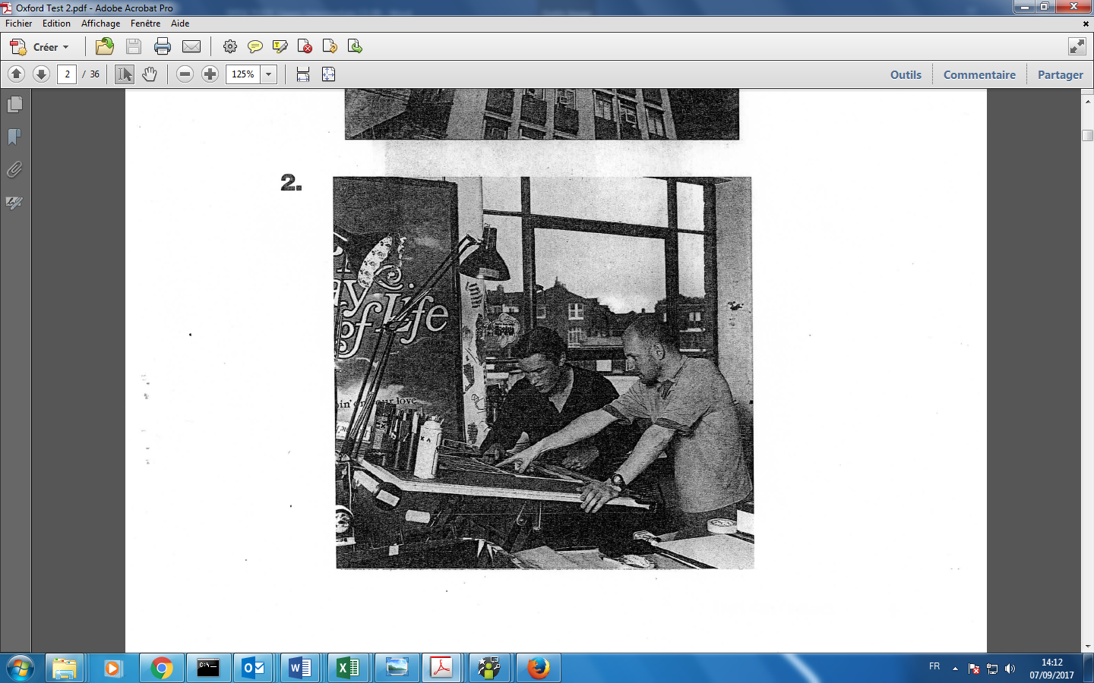

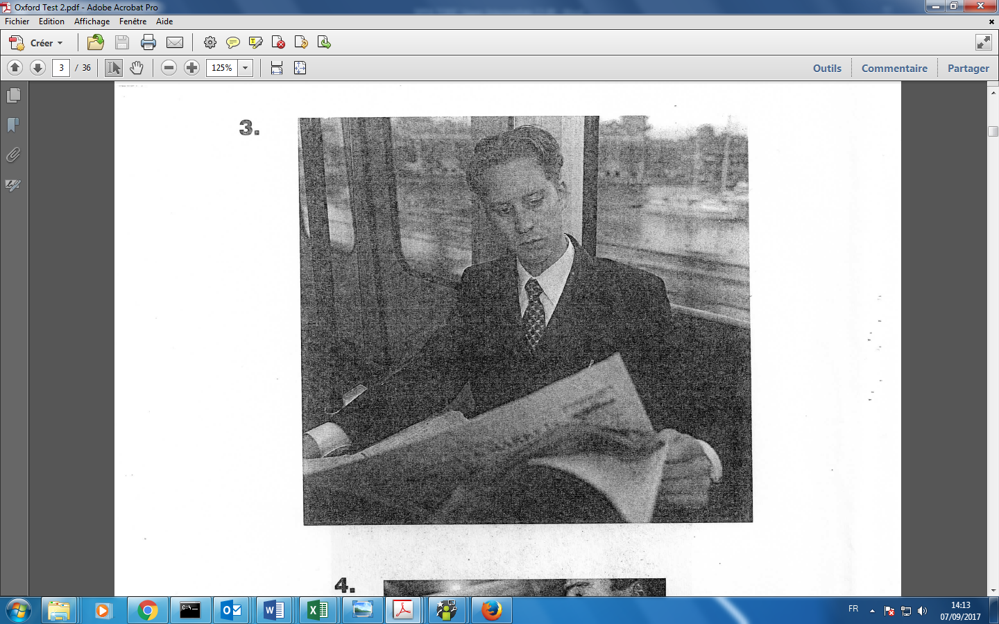

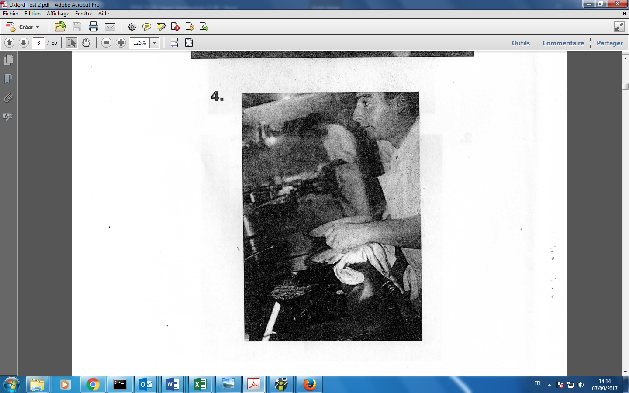

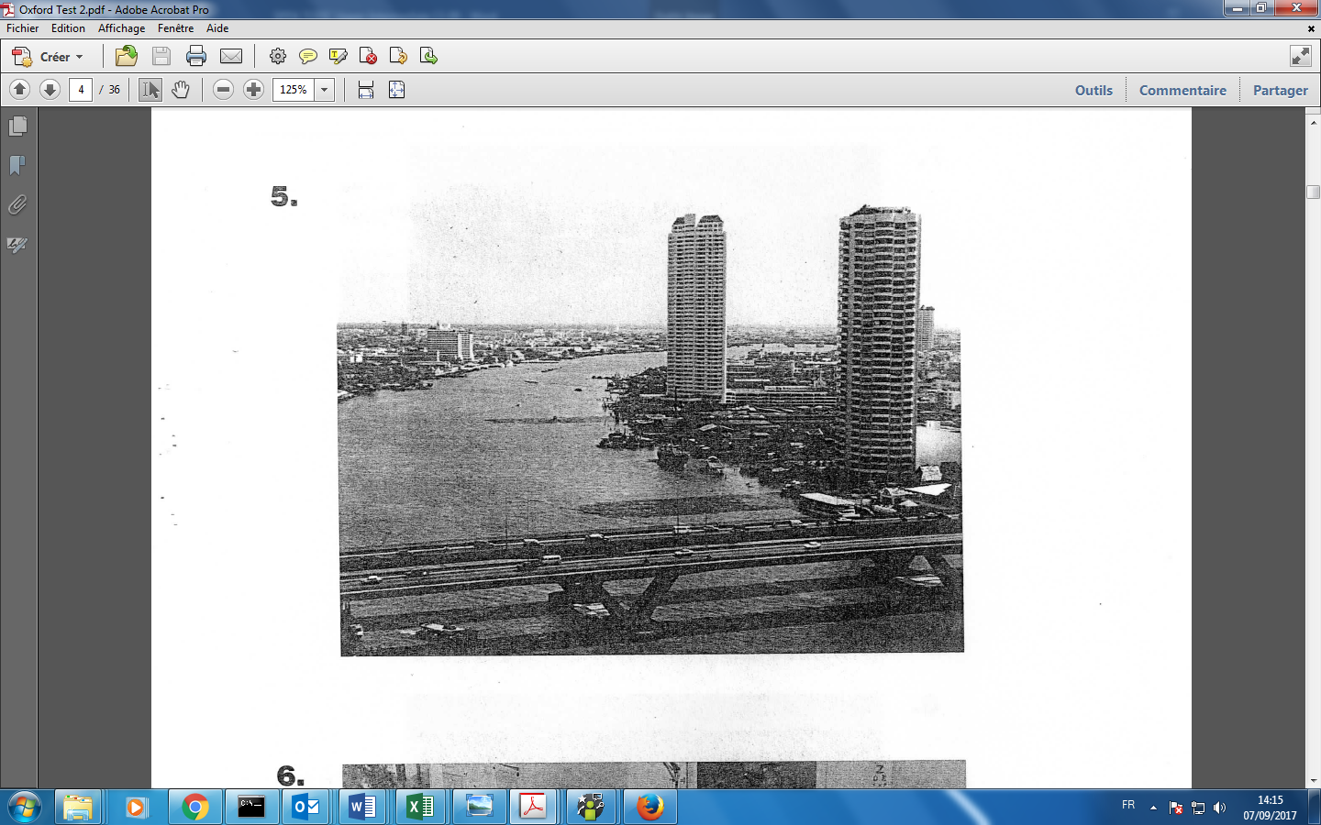

**Part 2**

**Questions 11-25**

**Part 3**

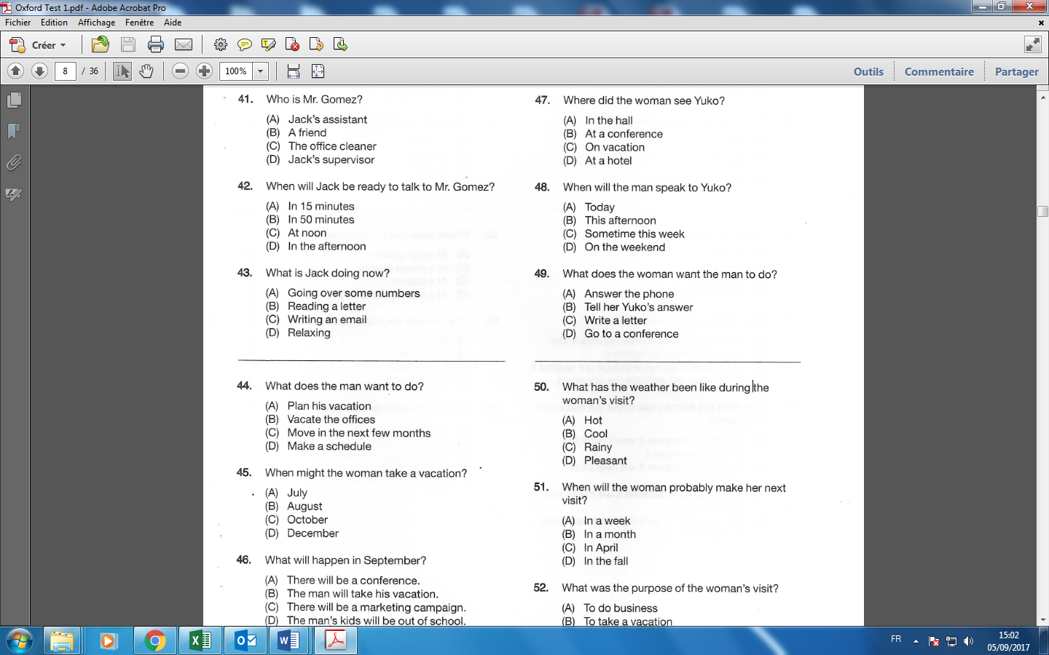

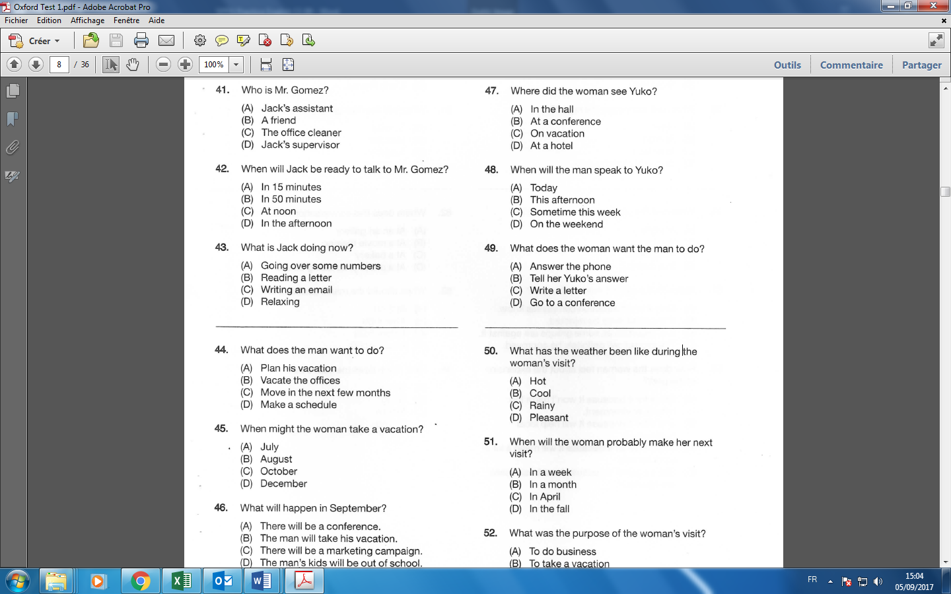

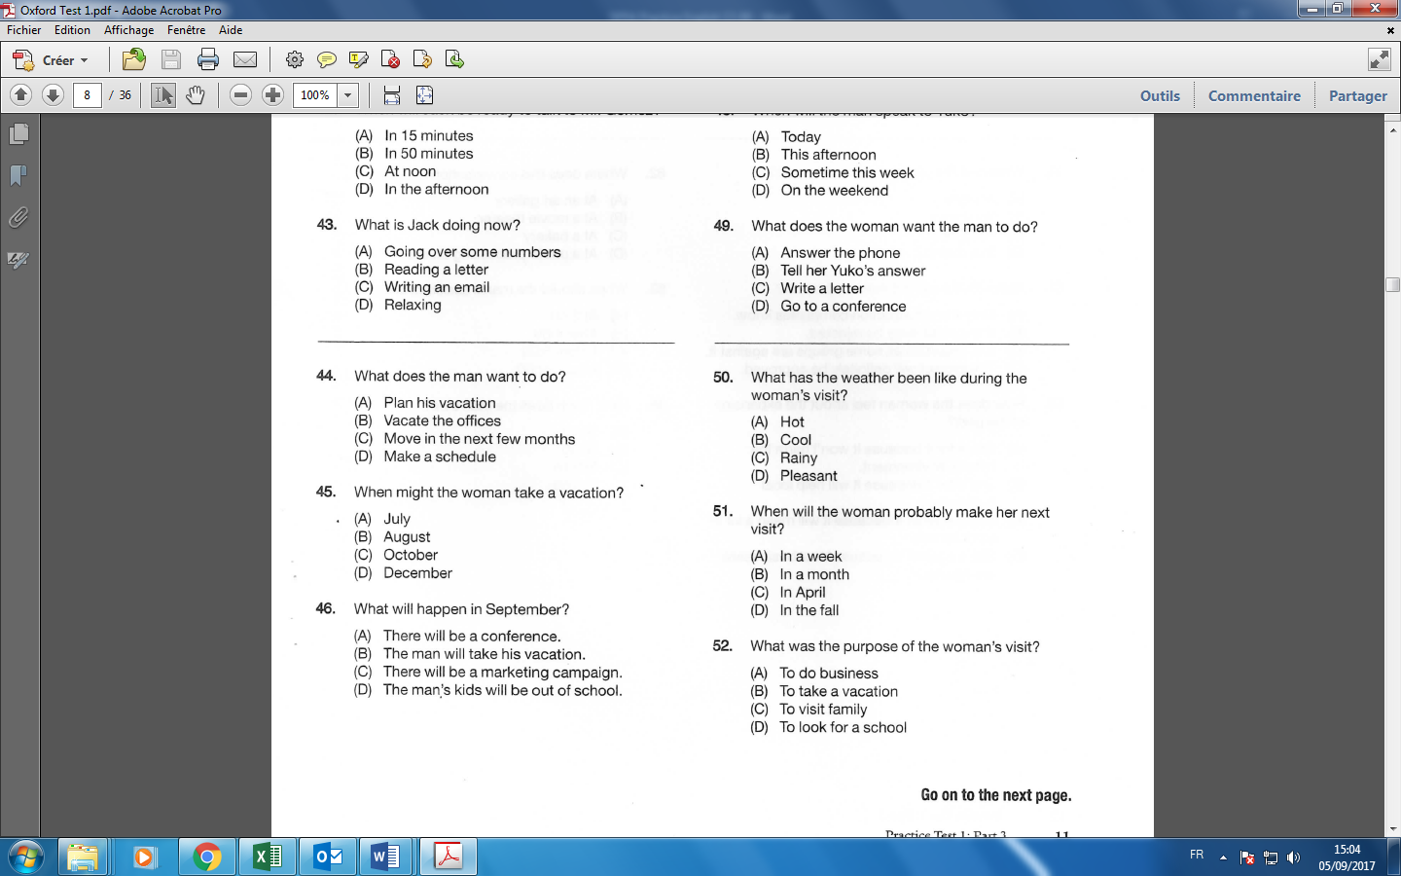

**Part 4 (Audio TOEICATOR 1 from 43.30 to 46.40)**







1. **GRAMMAR**

*INDICATIVE TENSES*

**Present simple /** Habitude – vérité générale (+ utilisation pour futur universel)

Every day she eat**s** snails. (She doe**s**n’t **eat** snails. / Doe**s** she **eat** snails?)

*Time indicators: every, always, sometimes, often, usually, never, rarely, seldom, hardly, once/twice a day*

Attention au « s » à la 3ème personne du singulier. Utiliser l’auxiliaire DO/DOES aux formes négative et interrogative suivi du verbe à l’infinitif (pas de « s » à la fin du verbe, le « s » n’est que dans l’auxiliaire)

**Past simple /** Action terminée, souvent datée

She **ate** snails yesterday. (She didn’t **eat** snails. / Did she **eat** snails ?)

*Time indicators: last, yesterday, ago, the day before, when (interrupted action)*

Attention aux verbes irréguliers (2ème colonne). Utiliser l’auxiliaire DID aux formes négative et interrogative suivi du verbe à l’infinitif (pas au passé)

**Present perfect simple /** Action qui se poursuit dans le présent + action dans le passé avec impact explicite ou implicite dans le présent + partage d’expérience (j’ai vu 3 fois…, je n ai jamais)

She has just eaten snails. (She hasn’t eaten snails. / Has she eaten snails ?)

*Time indicators : already, just, yet, ever, never, recently, lately* et pour dire DEPUIS *(since, for, how long)*

Attention aux verbes irréguliers (3ème colonne). Attention à bien utiliser « has » à la 3ème personne du singulier. Attention, ce temps ressemble au passé composé français dans sa forme mais pas dans son utilisation.

**Future simple /** Action future générale … idée en l’air (60% de chance de réalisation)

She will eat snails tomorrow. (She won’t eat snails. / Will she eat snails?)

*Time indicators: tomorrow, next, the day after, in the future, soon, in 3 minutes/days/months/years*

**Attention, pas de future en anglais après une conjonction de temps (when, once, as soon as…)**

**Past perfect simple /** Action antérieure à une action passée

She had eaten snails before she went to the restaurant. (She hadn’t eaten snails. /Had she eaten snails?)

**Future perfect simple /** Action future antérieure à une deuxième action future plus lointaine

When we reach the next village, we will have walked for 15 km

*Time indicators: before + past…*

**Tous les temps ci-dessus existent à la forme progressive pour insister sur la durée (“en train de”): She is eating / She was eating / She has been eating / She will be eating / She had been eating / Attention verbs d’état (to be, to own, to belong to, etc.)🡪 simple form sauf exception**

**TOEIC PROBLEMS**

**1 - Present simple or present continuous?**

1. She always (have) a coffee before attending a meeting.
2. He sometimes (forget) to send the monthly sales report.
3. Do not disturb her! She (check) the list.
4. Hurry up, she (wait) for you to start the meeting.
5. Please listen. Jack (summarize) the main points of the conference now.
6. He (interview) applicants: he always (interview) them early in the morning.
7. What is his job? Well, he (analyse) financial accounts and (prepare) reports.
8. Look, he is (take) notes! Really? He never (take) notes during meetings.

**2 - Past simple or past continuous?**

1. He (join) the company in 1999.
2. She (work) when I (leave) the office.
3. I (call) my boss to tell her I (decide) to quit.
4. She (tell) me about it 10 days ago.
5. While I (work) as an office assistant, I (learn) how to use several computer programs.
6. Mr Chang (interview) job applicants when I (arrive).
7. He (apply) for that position last week.
8. I (write) a cover letter when my boss (come) in.

**3 - Past simple or present perfect?**

1. They (vacate) the office last month.
2. We (work) here since last summer.
3. We (begin) to work here last summer.
4. Anne (join) the French office in 1991 and she (live) in Paris since then.
5. I (want) to be a lawyer when I was young.
6. I (never attend) an executive meeting but I (attend) a high level meeting last week.
7. John (be) head of the department for ten years. He wants to stay another three years.
8. Greta (stay) in the head office for ten years and then (go) to the Melbourne branch.
9. They (not sign) the lease yet.

**4 - Past simple or past perfect?**

1. The bus (already leave) when she (arrive) at the bus stop.

2. Pat (watch) TV after she (finish) her homework.

3. When I arrived at the car park, I (find out) that my car (disappear).

4. The children were amazed because they (see/never) a bear before.

5. By the time the film (end) Sonia (eat) a lot of popcorn.

6. We (have) the car for ten years before it (break) down.

7. She (understand) the film she saw yesterday because she (read) the book.

8. When Peter (go) to the theatre, he (discover) that all the seats (be sold).

**Test yourself**

<http://www.english-4u.de/tenses_ex1.htm>

**Part 5 - MINI QUIZ**

1- Martin Hogg __________ at the National Credit Bank since he first arrived in London in 1994.

1. worked
2. has been working
3. was working
4. had worked

2- We didn’t notice that the package was already damaged when it __________

1. arrived
2. has arrived
3. was arriving
4. had arrived

3- According to the financial report, CBC Ceramics __________ profits by about 30 million euros last year.

a) increase

b) increased

c) increasing

d) has increased

4- Serena and David are really __________ forward to helping their students with these exams.

1. look
2. looked
3. looking
4. looks

5- Since the beginning of the year, the sales __________

1. have risen
2. have raised
3. rose
4. raised

6- When I arrived at the car park, I found out that my car __________

1. have disappeared
2. disappeared
3. had disappeared
4. disappears

7- Please could you see Mr Thomson as soon as your performance review meeting __________

a) will end

b) ends

c) will be ending

d) will have ended

8- The new invoicing program __________ us to send out bills and process money more quickly last year.

1. allow
2. will allow
3. are allowing
4. allowed

9- Company profits __________ by 20% since we installed the new high-speed computer network.

1. rise
2. risen
3. rising
4. have risen

10- Albion Automotive __________ a two-year guarantee on all its products.

1. provide
2. provides
3. providing
4. provision

11- The CEO sent a memo __________ that his company would be implementing new pollution controls during the next quarter.

1. states
2. statement
3. stated
4. stating

12- The airport has __________ into a city in its own right, employing 53,000 people and covering an area of over 5 square miles.

1. growth
2. grow
3. growing
4. grown

**Part 6**

**Questions 141-143** refer to the following letter.

Ms. Monica Eisenman

555 King Street

Auckland

New Zealand

Dear Ms. Eisenman:

I am ------- to confirm our offer of part-time employment at Western Enterprises. In your role

**141.** (A) pleased

(B) pleasing

(C) pleasant

(D) pleasure

as research assistant, you will report to Dr. Emma Walton, who will keep you informed of your specific duties and projects.

As we discussed on the telephone, you ------- twice a month. Hourly employees working fewer **142.** (A) will pay

(B) were paid

(C) have paid

(D) will be paid

than twenty hours per week are not ------- to receive paid holidays, paid time off for illness, **143.** (A) tolerable

(B) liberal

(C) eligible

(D) expressed

or other employee benefits. Your employment status will be reviewed in six months.

If you have any questions, please feel free to contact me.

Sincerely,

*Christopher Webster*

Christopher Webster

Human Resources

Enclosures

1. **READING PART**

**Part 7**





